Name: Stephane Allen
ID#: 2306821
Occurrence: UE2
Course: Web programming
Tutor: Siri Badhika

Business Idea

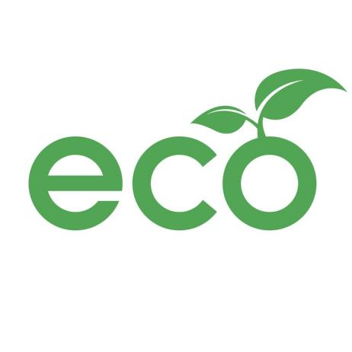
Name: Ecowares
Description: Ecowares is committed to providing environmentally friendly, sustainable, and zero-waste products that help consumers reduce their carbon footprint and live more eco-conscious lives. Our product range includes reusable bags, bamboo toothbrushes, bamboo straws, organic cotton tote bags, and compostable phone cases, all designed to promote sustainability without sacrificing style or convenience. At EcoWares, we believe in making eco-friendly choices accessible and stylish, empowering individuals to protect the planet one purchase at a time.

Slogan: "Sustainable Choices, Stylish Living."

Mission: EcoWares aims to inspire and empower individuals to adopt sustainable habits by offering eco-friendly products of high quality, affordability, and style. We are dedicated to reducing waste and conserving natural resources through innovative, environmentally conscious solutions.

Vision: To become a leading global provider of eco-friendly products that foster a zero-waste lifestyle, inspiring a world where sustainability is the norm and environmental impact is minimized.

Target Audience: EcoWares’ target audience includes environmentally conscious consumers of all ages, particularly Millennials and Gen Z, who prioritize sustainability, health, and ethical consumption. The color palette aligns with their values, instilling confidence and a sense of community around eco-friendly living.

Justification of Color Palette
The color palette of Ecowares is centered around natural, calming greens and earthly tones, carefully chosen to evoke specific psychological responses aligned with our brand values.

Primary Color – Green (#4CAF50):
Chosen for its strong association with nature, growth, renewal, and health.
Psychologically, green is calming, reassuring, and ties directly to eco-friendly initiatives, reinforcing trust and a sense of sustainability.
Used in headers and call-to-action buttons to encourage engagement and convey eco-consciousness.

Darker Green (#2e7d32):
Employed for headings and section titles, representing stability, prosperity, and a deeper connection with nature.
It provides contrast while maintaining harmony with the primary green.

Light Mint Background (#f0f8f5):
A soft, calming hue that evokes freshness, cleanliness, and serenity. It provides a neutral, eco-friendly backdrop that doesn’t overpower content, making the website inviting and soothing, encouraging visitors to explore eco-conscious choices comfortably.

Accent and Text Colors (#333, #555):
Dark gray tones for body text ensure good readability without the harshness of pure black, aligning with a gentle, natural aesthetic.

Buttons & Highlights – Green Shades:
Consistent with the brand’s eco-theme, creating a cohesive look that emphasizes action and positivity.

Summary
Informed by the psychology of color in web design, the palette creates a trustworthy, calming, and environmentally aligned atmosphere that encourages users to feel good about making sustainable choices. The vibrant greens attract attention to calls to action (buttons, headers), while the softer backgrounds promote relaxation and trust.

Link addresses for photos
Logo - https://www.google.com/url?sa=i&url=https%3A%2F%2Fwww.freepik.com%2Ffree-photos-vectors%2Feco-logo&psig=AOvVaw3HuDJQG6Wc202MBr91IQXL&ust=1762470700450000&source=images&cd=vfe&opi=89978449&ved=0CBUQjRxqFwoTCKi20ZKR3JADFQAAAAAdAAAAABAE

Products
Reuseable bag - https://www.google.com/url?sa=i&url=https%3A%2F%2Fdaksindia.com%2Fchoosing-a-reusable-bag-manufacturer&psig=AOvVaw3nsKtqARVWgk_DdsQA3AvJ&ust=1763775909641000&source=images&cd=vfe&opi=89978449&ved=0CBUQjRxqFwoTCJDw87aPgpEDFQAAAAAdAAAAABAE

Bamboo Toothbrush - https://www.google.com/url?sa=i&url=https%3A%2F%2Fwww.ecofreaky.com%2Fproducts%2Fset-of-5-eco-friendly-kids-bamboo-toothbrushes-soft-bristles%3Fsrsltid%3DAfmBOopYVIlvH6WHQHPuLPrqv0qKAC6OeXN_uE-rk-hPtDeBo8c1YJcI&psig=AOvVaw0J2XUGdJ6G5OoEba0MapG8&ust=1763775958310000&source=images&cd=vfe&opi=89978449&ved=0CBUQjRxqFwoTCIiP682PgpEDFQAAAAAdAAAAABAE

Bamboo Straw - https://www.google.com/url?sa=i&url=https%3A%2F%2Fjungleculture.eco%2Fproducts%2Fcustom-branded-bamboo-straws-for-businesses%3Fsrsltid%3DAfmBOoqad3UpYW1sY8-YQVvFmT2Pmpxh4wmvmB8ebn-HaH6AfwH0NYWW&psig=AOvVaw0liVYKpVNEadpW9JAnZKrS&ust=1763776047046000&source=images&cd=vfe&opi=89978449&ved=0CBUQjRxqFwoTCPjHsfuPgpEDFQAAAAAdAAAAABAM

Organic Cotton Tote Bag - https://www.google.com/url?sa=i&url=https%3A%2F%2Fwww.publicgoods.com%2Fproducts%2Freusable-cotton-tote-bag%3Fsrsltid%3DAfmBOoquFnI0so92GIj0wMoi1cwuNkUDXQK3Y-YSZnNQPwxnsmQnJFFw&psig=AOvVaw1kQk5A2jq64s6t1PA1h3YT&ust=1763776126125000&source=images&cd=vfe&opi=89978449&ved=0CBUQjRxqFwoTCOiSlp2QgpEDFQAAAAAdAAAAABAE

Compostable Phone Case - https://www.google.com/url?sa=i&url=https%3A%2F%2Fviable.earth%2Flifestyle%2Fpela-creates-100-per-cent-compostable-phone-cases%2F&psig=AOvVaw0ZOsZSbuBJqZ5kn39VCeuA&ust=1763776164122000&source=images&cd=vfe&opi=89978449&ved=0CBUQjRxqFwoTCJj9wLmQgpEDFQAAAAAdAAAAABAM

